**Data Visualizations**

|  |  |
| --- | --- |
| Technology : | Data Analytics |
| Team ID : | PNT2022TMID18166 |
| Project Name : | Analytics for Hospitals' Health-Care Data |

**TOPICS**

1. **Number Of Patients By Ward Types**
2. **Dashboard To Show Number Of Patients**
3. **Age Wise Patients With Department And Severity Filters**
4. **Dashboard With Hierarchy Bubble And Radial Visuals**
5. **Dashboard Showing Pie, Stacked Bar, Waterfall And Pie Charts**

# Number Of Patients By Ward Types

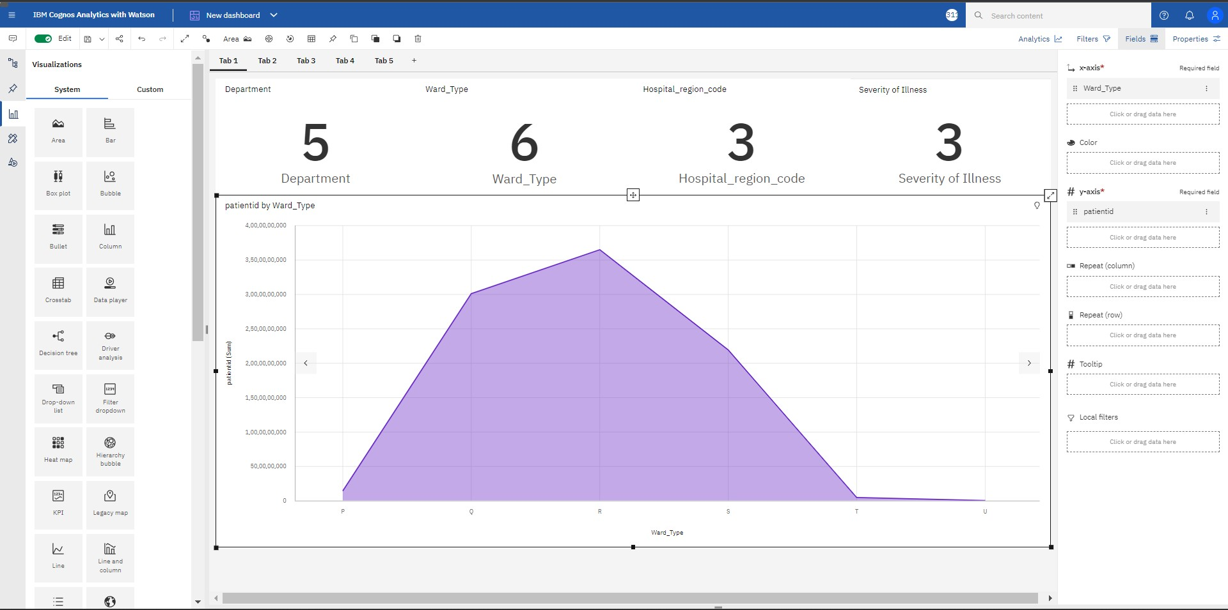

1. **Dashboard To Show Number Of Patients**

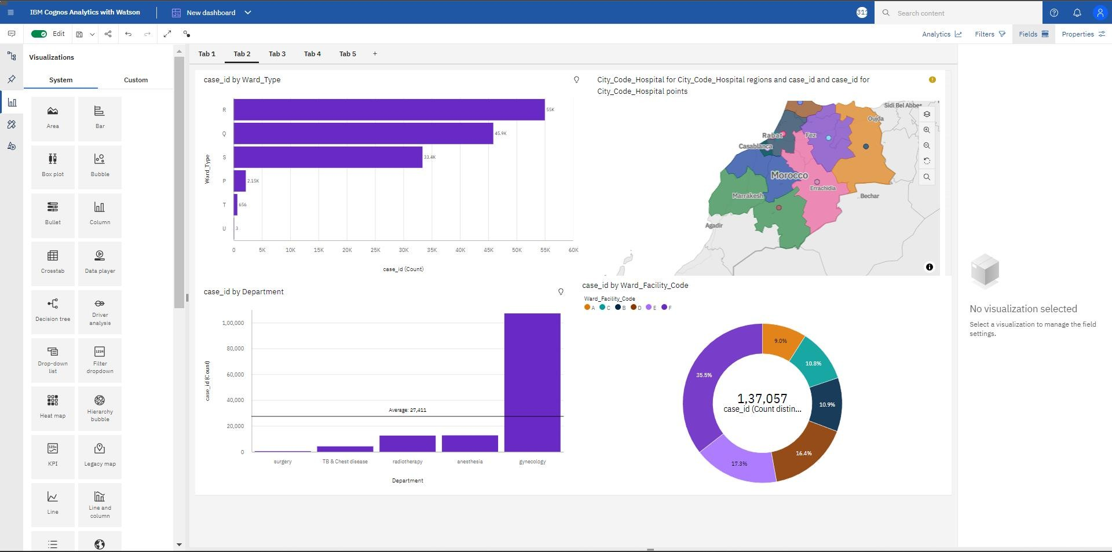

1. **Age Wise Patients With Department And Severity Filters**

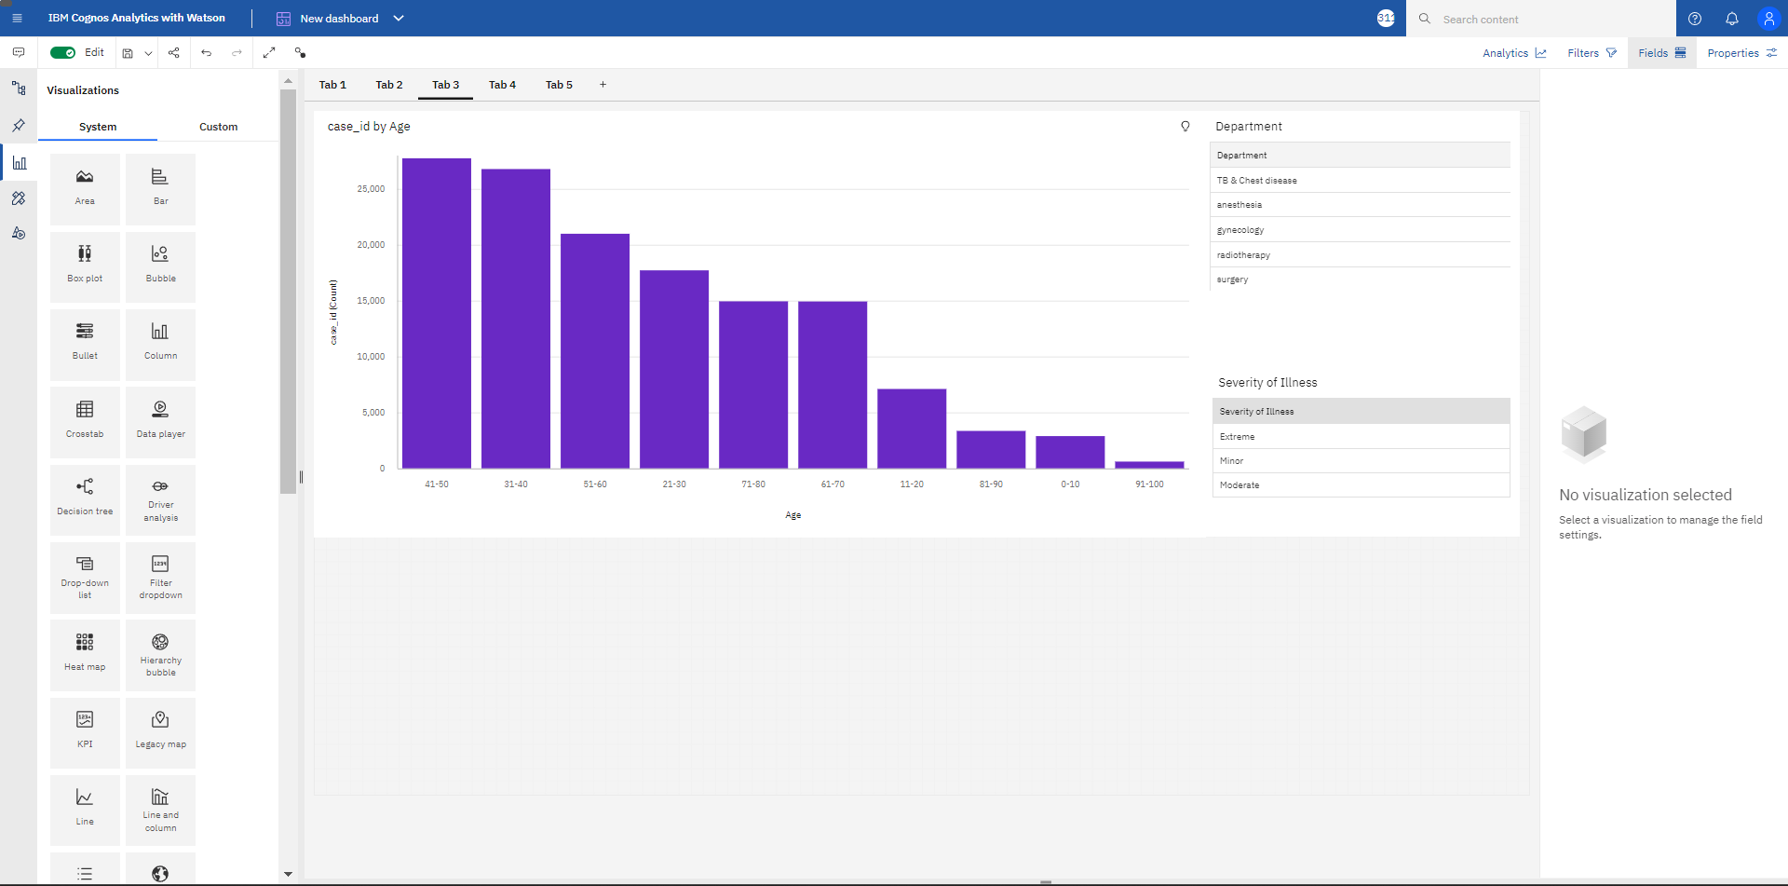

# Dashboard With Hierarchy Bubble And Radial Visuals

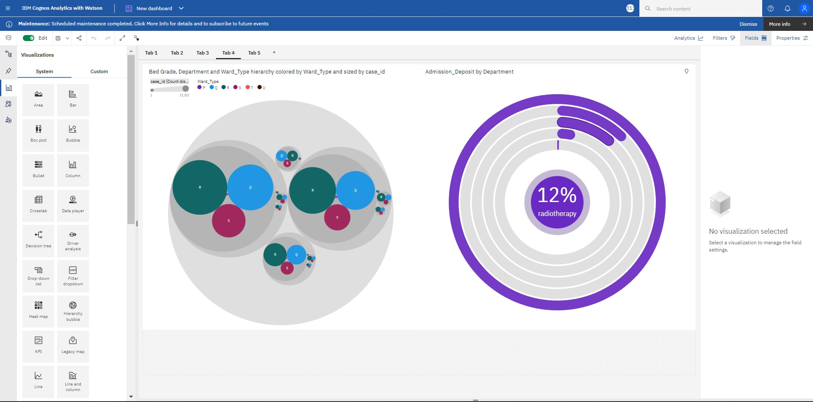

1. **Dashboard Showing Pie, Stacked Bar, Waterfall And Pie Charts**

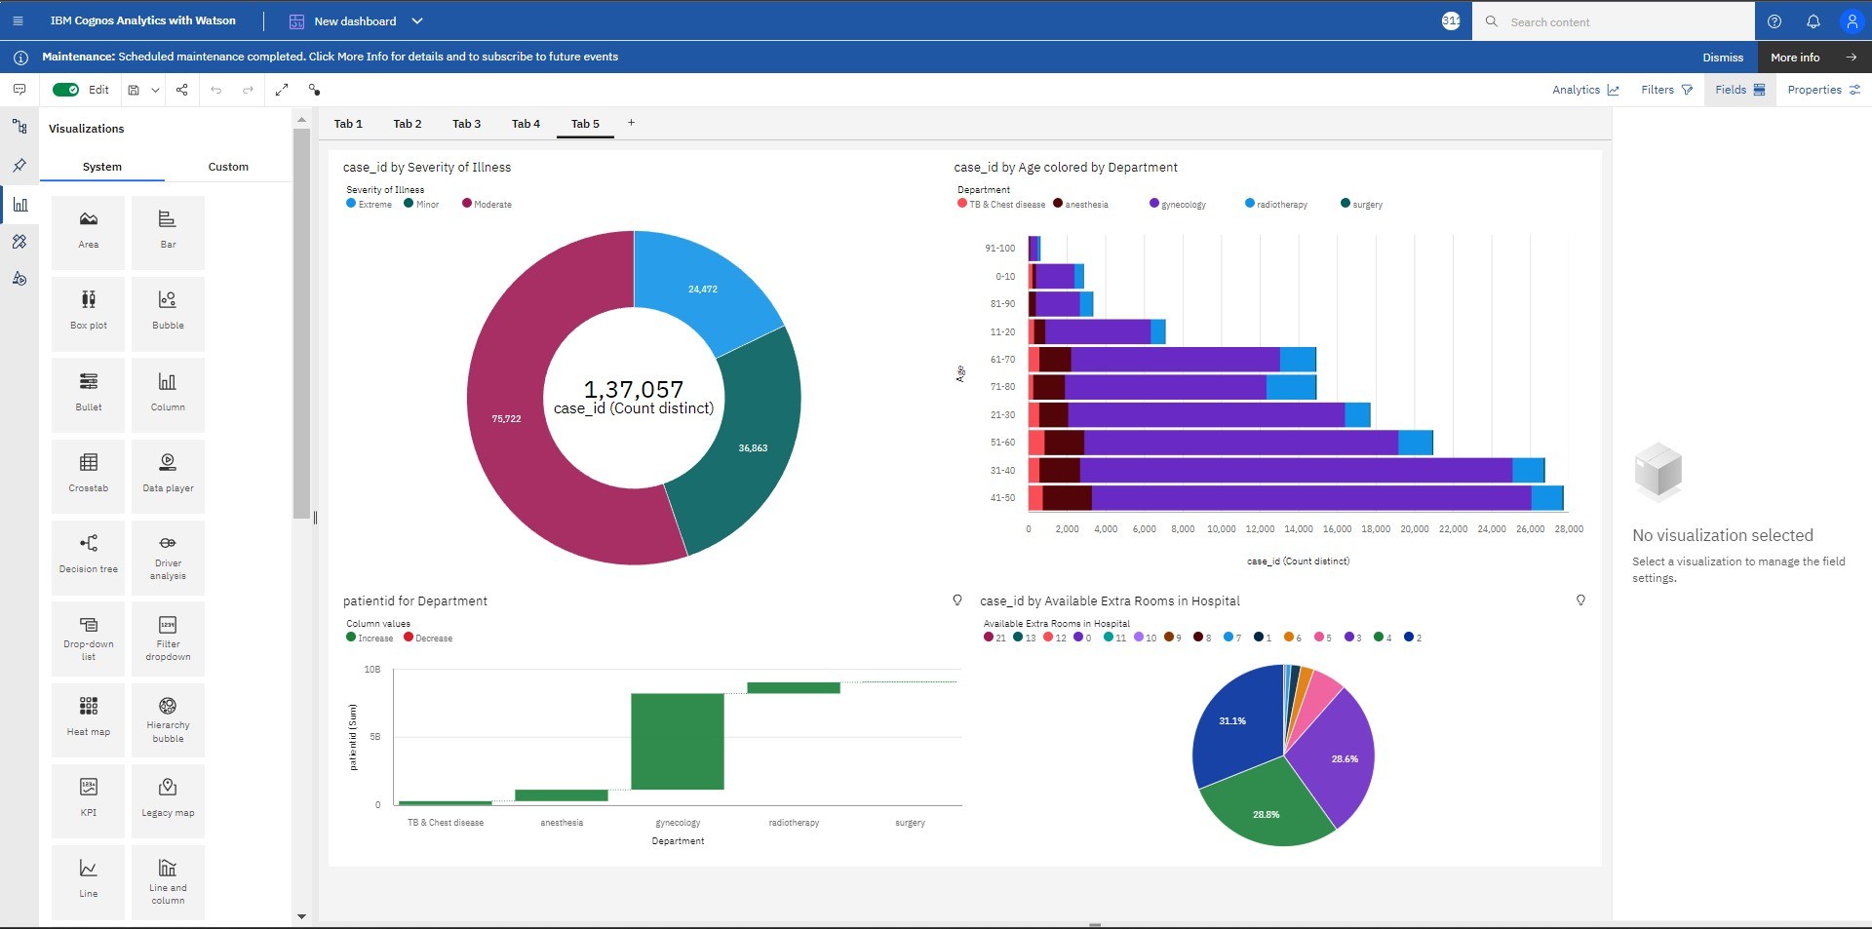

Data visualization Links:

https://us3.ca.analytics.ibm.com/bi/?perspective=dashboard&pathRef=.my_folders

%2Fvisu%2FNew%2Bdashboard&action=view&mode=dashboard&subView=model00 00018432032598_00000002